Lab 4

Ex1:

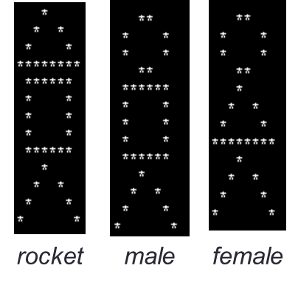

Write the following functions

**void drawTriangle();**

**void drawRectangle();**

**void drawCircle();**

**void drawInvertedV();**

in main(), call the above functions appropriately to draw Rocket, Male, and Female

Ex2: write a function to convert a value in inches to centimeters

**double inchToCm(double);**

Call the function in main() to test

*Note: Do NOT use System.out.println in function.*

*Use System.out.println only in main()*

Sample run:

***Enter the distance in inches: 3***

***3.00 inches = 7.62 cm***

Ex3: write a function to convert a value in Fahrenheit to Celsius

**double fToC(double);**

Call the function in main() to test

*Note: Do NOT use System.out.println in function.*

*Use System.out.println only in main()*

Sample run:

***Enter temp in Fahrenheit: 98.4***

***Temp 98.4 in Fahrenheit = 36.89 Celsius***

Ex4: write a function to check a year is a leap year or not

**boolean isLeapYear(int);** //return true or false

write a program for users to key in a year then print out it is a leap year or not using the above function

users must key in 0 or a negative number to end the program.

*Note: Do NOT use System.out.println in function.*

*Use System.out.println only in main()*

Sample run:

***Enter a year: 1947***

***It is NOT a leap year.***

***Enter a year: 2012***

***It is a LEAP year***

***Enter a year: 0***

---------------------

Ex5: write a function for users to key in 03 **distinct** integers and the function will return the smallest number of all.

**int getSmallest(int, int, int);**

Write a program for users to key in 3 numbers and print out the smallest number using the above function

Users must key in 2 equal numbers to end the program

*Note: Do NOT use System.out.println in function.*

*Use System.out.println only in main()*

Sample run:

***Enter 3 integers: 12 3 11***

***3 is the smallest.***

***Enter 3 integers: 121 442 199***

***121 is the smallest.***

***Enter 3 integers: 0 1 1***

---------------------

Ex6:

Write a program **magicNumber.java** to read two positive integers, each with at most 5 digits, and for each integer, add up the digits (from right) in positions 1, 3 and 5. The right-most digit of the sum is the required answer.

*For example, if the input is 76524, then adding up the digits 4, 5 and 7, we get 16.*

*The answer is hence 6.*

Your program should contain a function **getMagic(…)** to compute and return the answer.

You are to decide on its parameter(s).

Sample run:

***Enter 1st value: 76524***

***Magic number = 6***

***Enter 2nd value: 8946***

***Magic number = 5***

Ex7:

Write 2 functions

* **boolean containDigit7(int); //**return true if the input has digit 7; otherwise return false
* **int sumWithout7(int);** //return the sum of all integers from 1 to n (input), excluding those have digit 7

Hint: **sumWithout7()** will call **containDigit7()** while calculating the sum.

Write main() calling **sumWithout7()** to test.

Sample run 1:

***Enter n: 10***

***Sum without 7 is: 48***

Sample run 2:

***Enter n: 20***

***Sum without 7 is: 186***

Ex8: (nested loop)

Write function **printMenu()** to print the menu below

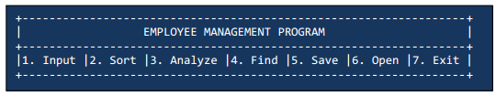

Write function **toContinue()** to print the question below

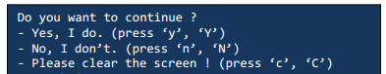

In main(), do the following steps:

Step 1: print the above menu using **printMenu()**

Step 2: ask users to key in their choice (“Please enter your selection: ”)

If users type in invalid input, ask again until they key in correctly.

Step 3: print out: “You have selected xxx” in which xxx is users’ selection

If users type in 7, the program should end.

Step 4: print the question using **toContinue()** then wait for users to key in the answer.

if users choose Yes, the program goes back to step 1

if users choose No, the program should end

if users choose ‘C’ or ‘c’, call system function **system("cls");** then go back to step 1.

if users type in invalid input, ask again until they key in correctly.